Hiawatha’s 2019 Charity Drive

Thank you to everyone who took part in this year’s Charity Drive.

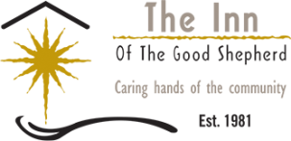
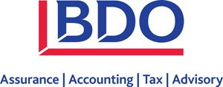
Representative: Scott McKay
Driver: Tyler Borth
Charity: Inn of the Good Shepherd
Wins Since May 4: 28
$280 for the Inn of the Good Shepherd
BDO Canada LLP, (‘BDO’) is one of the largest accounting and advisory firms in the Sarnia-Lambton area, and also in Canada. It provides strong accounting and tax services to a wide variety of clients, with a focus on owner-managed businesses.
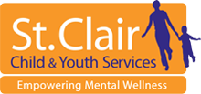
Representative: Barry Hogan
Driver: Garrett Rooney
Charity: St Clair Child and Youth Services
Wins Since May 4th: 34
$340 for St Clair Child and Youth Services
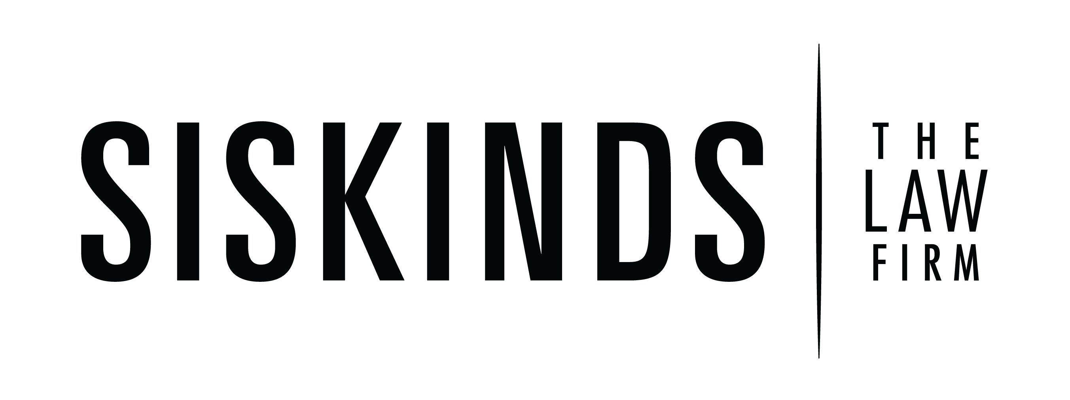Gamble Insurance was founded in Sarnia in 1948 by Bill Gamble. In 2015, Gamble Insurance across Southwestern Ontario joined the HUB International family. HUB International specializes in personal insurance, business insurance, farm insurance, and employee benefits. They balance the strength of an international firm of over 12,000 employees with the accessibility of a local broker. As a whole, HUB International is a knowledge powerhouse providing you with tailor-made solutions that draw on their collective skills and expertise.
Representative: Raymond Leach
Driver: Andy Moore
Charity: Sarnia Arena Revitalization Project
Wins Since May 4th: 8
$80 for the Sarnia Arena Revitalization Project
Siskinds LLP serves individuals, families and businesses in southwestern Ontario and across Canada from our offices in Sarnia, London, Toronto and Québec City. We are a team of over 230 lawyers and support staff who cover family law, business law, litigation, personal injury and class actions as well as over 25 specialized areas of law. As one, we are focused on helping you manage your legal needs, connect the dots where needed, and generally make life a little less complex by providing you with the expertise you need within one law firm.

