**Hiawatha Charity Drive**

[](https://www.google.ca/url?sa=i&rct=j&q=&esrc=s&source=images&cd=&cad=rja&uact=8&ved=2ahUKEwjwyNCW97LaAhUE34MKHfo-CJAQjRx6BAgAEAU&url=https://mdaalberta.com/associate-members/&psig=AOvVaw0-DXZ-DylsrG9lQBtuqxRm&ust=1523560415228627) 

and and

**Andy Moore** **Garrett Rooney**

are raising money for are raising money for

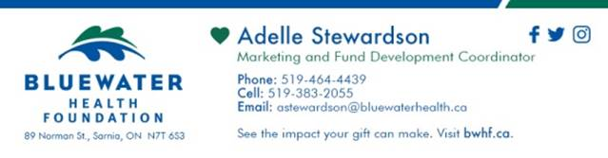 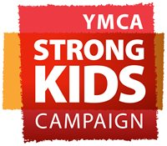

Wins since May 5th: **6** Wins since May 5th: **42**

HUB will be donating $420 to the YMCA Strong Kids Campaign.

BDO will be donating $60 to the Bluewater Health Foundation.

The kind people at BDO decided to match HUB’s donation.

BDO will be donating $420 to the Bluewater Health Foundation.

**Thank you to everyone who participated.**